Assignment-1
Name: Ajeeb Kunhuty Abdul Raheem
Email: ajkeducat@gmail.com

Number Classification
Write a shell script that uses a function to check whether a number is positive, negative, or zero using if.
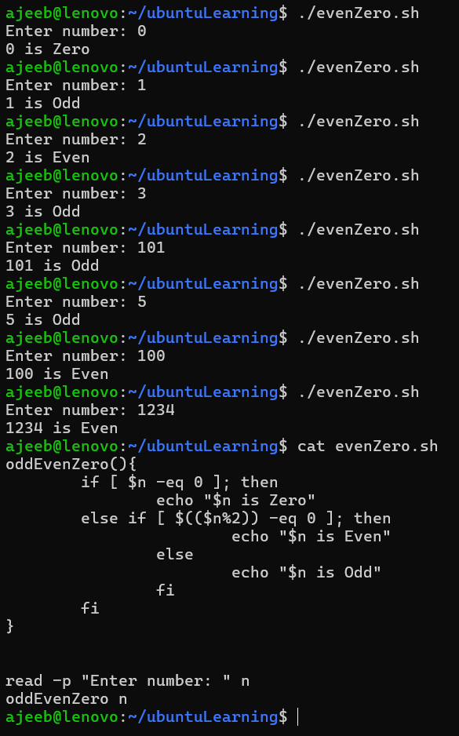

Factorial of a Number
Write a shell script to calculate the factorial of a number using a while loop inside a function.
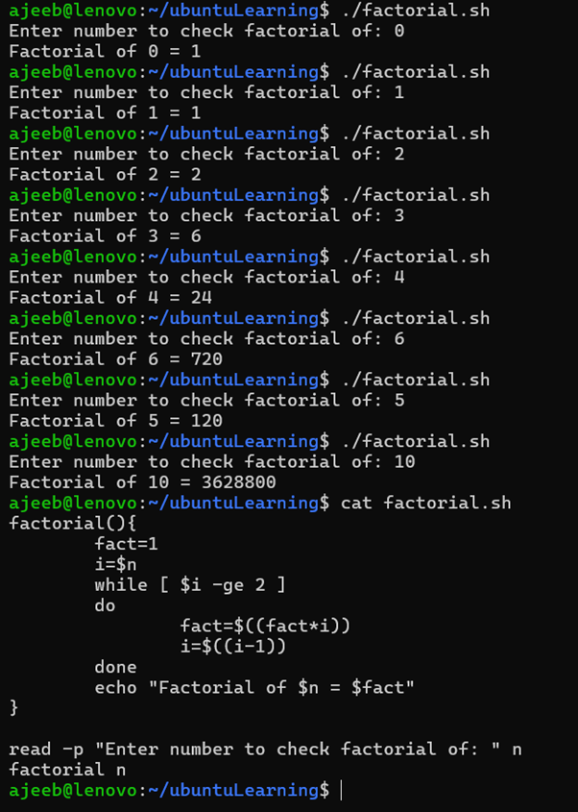

Sum of N Numbers
Write a shell script to calculate the sum of numbers from 1 to N using a for loop inside a function.
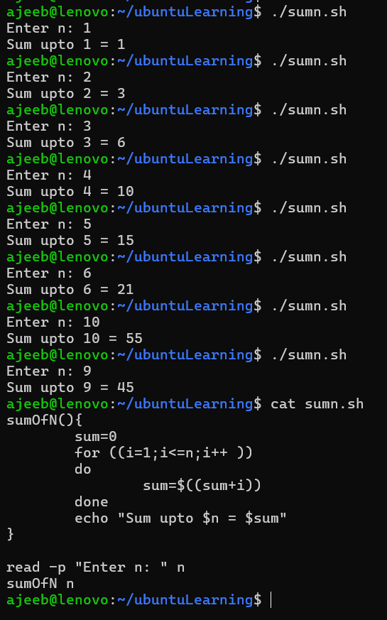

Prime Number Check
Write a shell script that uses a function to check whether a given number is prime using if and for.
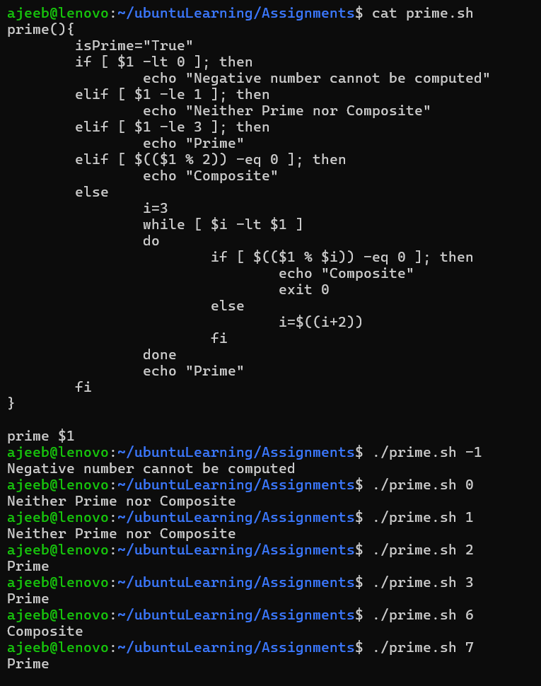

Reverse a Number
Write a shell script to reverse a number using a while loop and if conditions where required.
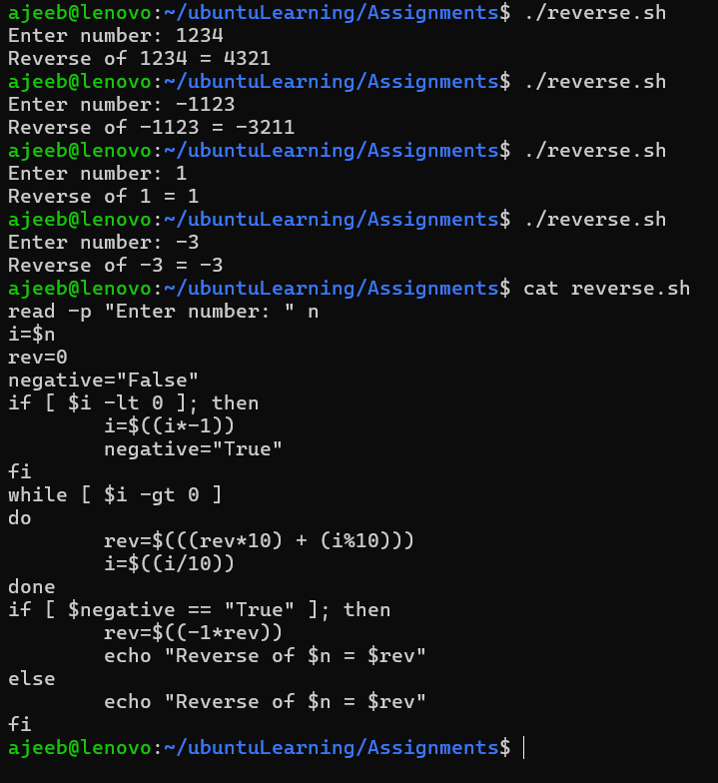

File Existence and Permission Check
Write a shell script that uses a function to check if a file exists and whether it has read, write, and execute permissions.
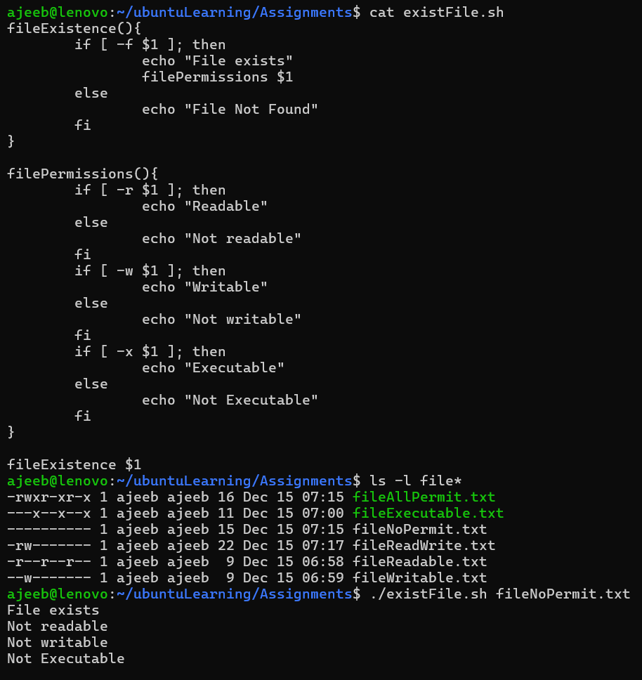
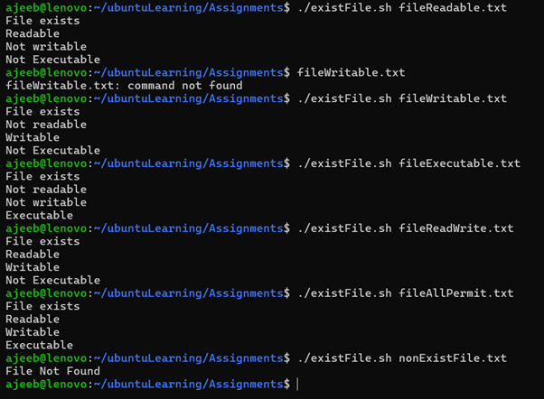

Please Turn to Next Page

Menu-Driven Calculator
Write a shell script that shows a menu in a while loop and performs add, subtract, multiply, divide using functions.
